[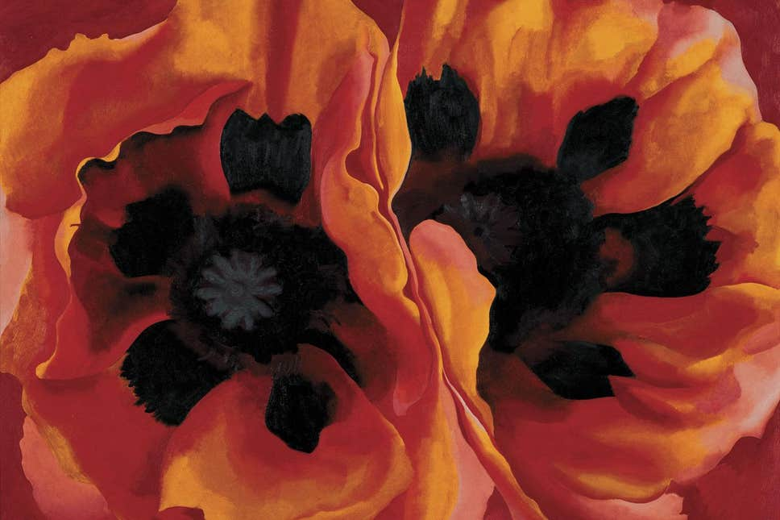](https://www.google.co.uk/url?sa=i&url=https%3A%2F%2Fwww.standard.co.uk%2Fgo%2Flondon%2Farts%2Fgeorgia-okeeffe-review-the-artist-who-tried-to-create-a-new-kind-of-painting-for-modern-america-a3288001.html&psig=AOvVaw2RdsDwKRDM9Dmb3MotfYIb&ust=1597843259846000&source=images&cd=vfe&ved=0CAIQjRxqFwoTCIjK6ZrspOsCFQAAAAAdAAAAABAK)[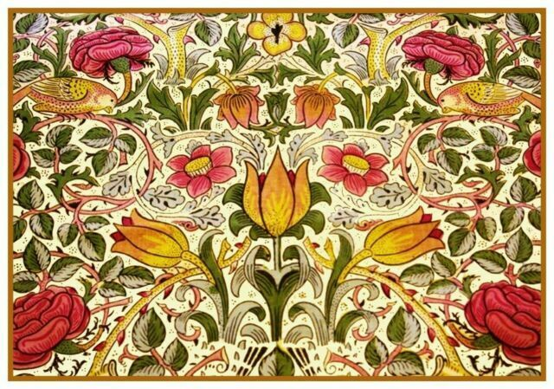](https://www.google.co.uk/url?sa=i&url=https%3A%2F%2Fwww.ebay.com%2Fp%2F1162448787&psig=AOvVaw2Pq-kIyql7yn0_7v4Dcn31&ust=1597843625829000&source=images&cd=vfe&ved=0CAIQjRxqFwoTCNjB7cLtpOsCFQAAAAAdAAAAABAG)

Supporting experiences:

Research different artists such as Georgia O’Keefe and William Morris.

Explore the outdoor area to find inspiration for their own art.

Key facts to retain:

* How different artists have painted flowers.
* Different parts of a flower.
* Know how to draw a flower using accurate proportions.
* How to use watercolour.
* How to hold a pencil properly.

What I should already know:

* How to hold a pencil
* The name of some famous artists
* Some artistic vocabulary
* The names of the primary and secondary colours
* The different tools and equipment to use to create different effects.
* The names of different media (paint, charcoal etc)
* The parts of a flower.

Newall Green Primary School: Knowledge Organiser

Art: painting, sculpting and creating flowers. Term: Autumn 1

Year group: **6** Date: September 2020

Focus: painting, sculpting and creating flowers.

Key vocabulary:

Proportion: how parts of the flower compare to each other in relation to size, shape, colour.

Scale: the size of the parts of an object in relation to other parts.

Perspective:  what gives a three-dimensional feeling to a flat image such as a drawing or a painting

Expressionism:  refers to **art** in which the image of reality **is** distorted in order to make it expressive of the **artist's** inner feelings or ideas.

Medium: A **medium** refers to the materials that are used to create a work of **art**. The plural of **medium** is **media**. Some of the most common **media** are oil paints (paints that use oil to hold pigments together), tempera (pigments held together with egg yolk), marble (soft, white stone), and bronze (a metal used to cast sculptures)

Flowers by Georgia O’Keefe

Flowers by William Morris